M
WORD & EXCEL 2021
FOR BEGINNERS & ADVANCED LEARNERS

MICROSOFT

A STEP-BY-STEP GUIDE
TO MASTERING WORD &
EXCEL 2021

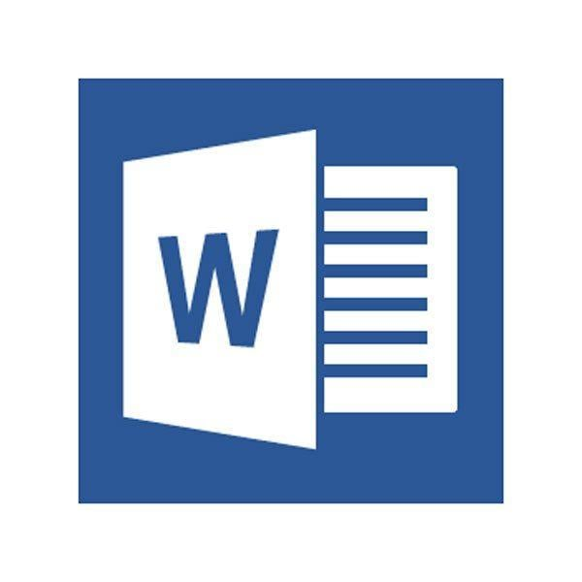

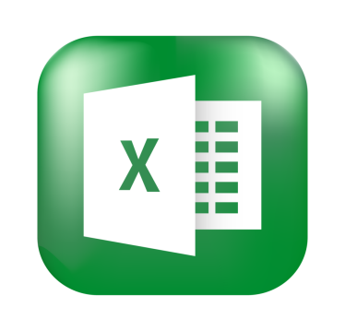


PETER JOHN

